**FPT ACADEMY INTERNATIONAL**



## FPT – APTECH COMPUTER EDUCATION

**DCakeShop**

|  |  |  |  |
| --- | --- | --- | --- |
| **Center Name** | | FPT – Aptech – HCM2  Address: 590 Cach Mang Thang Tam, District 3, Ho Chi Minh City | |
| **Instructor** |  | Ms. Le Mong Thuy |  |
| **Class** |  | T1.2303.M0 |  |
| **Group** |  | 7 |  |
| **Group members** | | **Name** | **Student ID** |
|  |  | Ta Hai Luong | Student1459114 |
|  |  | Nguyen Tat Thien | Student1459122 |
|  |  | Nguyen Khanh Danh  Dang Quang Khanh | Student1459128  Student1441452 |
| **Duration** | Start date | 19th June 2023 |  |
| End date | 26th July 2023 |  |

**This is to certify that**

**Mr.:**

Ta Hai Luong

**has successfully designed & developed**

eProject: DCakeShop website

**Submitted by:**

Ta Hai Luong

**Date of issue:**

**Authorized Signature:**

**TABLE OF CONTENTS**

****FPT – APTECH COMPUTER EDUCATION 1****

****TABLE OF CONTENTS**** ****2****

****ACKNOWLEGMENT**** ****3****

****SYNOSIS**** ****3****

****PROBLEM DEFINITION**** ****3****

****CUSTOMER'S REQUIREMENTS SPECIFICATIONS (CRS) 4****

****Business/Project Objective**** ****4****

****Hardware/ Software Requirements**** ****5****

****SCOPE OF THE WORK (IN BRIEF) 6****

****Architecture and design of the system 7****

****Diagram of the website 8****

****TASK SHEET REVIEW 1 9****

****SITE MAP 10****

****MOCK OF THE WEBSITE 1********1****

***1. Homepage 1******1***

***2. Shop 1******2***

***3. About 1******3***

***4. Blog 15***

***5. Contact 1******6***

***6. Searching bar 1******7***

***7. Cart 1******8***

***8. Login/Logout 19***

****TASK SHEET REVIEW 2 20****

WEBSITE DESCRIPTION ****21****

RESPONSIVE****28****

[****JAVASCRIPT DESCRIPTION****](#Javascript) ****30****

****TASK SHEET REVIEW 3**** ****47****

# ACKNOWLEGMENT

On behalf of team members. I would like to thank everyone who supported my team to successfully complete this eProject report. Especially, our teacher, she has supported us a lot since we started studying at FPT Aptect. With this eProject, she guided us very meticulously, enthusiastically and strictly. With her guidance, we were able to successfully complete this project. Besides, I also want to thank all the team members, each of whom worked hard to complete the eProject in earnest during the month of working together. Finally, our group would like to say thank you to my classmates and family for sharing and creating for the group the best environment to focus on the project, motivating the members to achieve their goals.

# SYNOSIS

# The goal of eProject was that we needed to create a website that would fulfill all the requirements of our client, DCakeShop. DCakeShop is a shop that specializes in providing all kinds of bakery products. They always satisfy customers with professional staff with many years of experience. The main goal of this website is to reach customers who need the best quality bakery products to each customer. In addition, the product also has discounts and promotions for customers, especially the store supports direct delivery to customers. Customer satisfaction is always the top goal of DCakeShop.

# 

# PROBLEM DEFINITION

The website should cover the following links / pages:

1. **Home page:** The page should be designed with a banner at the top of the page. The home page should cover a brief description of the entire website / presentation as well as a brief history of cake.
2. **About us:** divide the page into three sections vertically. Provide the foundation, mission and vision on these sections.
3. **All products:** the product page should be designed with all the products / thumbnails along with brief details of the individual products, such as
   1. Item code
   2. Price
   3. Egg less/with Egg
   4. Order button
4. On click on the order button a purchase form page should appear on a new browser window. The purchase form page should have all the form fields to capture the entire transaction and the users' details like
   1. Name
   2. Address
   3. Contact number
   4. Item code
   5. Quantity
   6. Delivery address
   7. Delivery Date
5. On click on the zoom button an enlarged image of the same product should appear on a new browser window.
6. **Products by event:** provide a categorized sub-navigation on this page such as
   1. Birthday
   2. Anniversary
   3. Engagement
   4. Marriage and so on.

Each and every sub-navigational button should be linked to an individual page. All the individual page should be designed with selected / categorized thumbnails along with brief details of the individual products, such as item code, price, zoom and order button.

1. On click on the order button a purchase form page should appear on a new browser window. The purchase form page should have all the form fields to capture the entire transaction and the users’ details.
   1. Name
   2. Address
   3. Contact number
   4. Item code
   5. Quantity
   6. Delivery address
   7. Delivery Date
2. On click on the zoom button an enlarged image of the same product should appear on a new browser window.
3. **Site Map:** The site map page should contain the entire navigational structure / diagram in a visual form and all the links (page names) of the diagram should be programmed for hyperlink to the respective pages.
4. About us, Contact Us, Disclaimer must be included. “Contact Us” page should have the Address of the Company and the mail address which when clicked will invoke the local mail client from where they can send an email. Address of the Company should be displayed using GeoLocation API (eg. GoogleMaps)
5. Creating an account facility can also be added.
6. Dummy procedure for buying to be added.

# CUSTOMER'S REQUIREMENTS SPECIFICATIONS (CRS)

**Client: DCakeShop**

### Business/Project Objective:

The store advertises by drop distribution, KOL, tik tok, media advertising, etc. In order to easily reach the customers and serve the best, the store decided to launch a website where everyone will get all the information about the different products available to them easily.

We have set up a website for them with the updated required specifications below:

The website will be developed cross-platform using HTML5, JavaScript and Geolocation. The website will work fine in all the leading browsers including Chrome, IE, Firefox, etc.

**Input to the system:**

- Search for products based on customer needs.

- Register as a member on the website.

- Feedback on product quality

- Information about customers ordering products.

**Output from the system:**

- Perform search by: product name, product type, products by event, ...

- Display results for each product type according to the search content.

- Display product information by price, quantity, size, egg less/with egg, ..

- Display the special information of the product.

- Displaying similar products and other related products.

- Display products that are on sale.

- Display button so customers can view product details.

- Customers can also add products to the cart and pay the bill on the website.

- The website may provide a brief introduction/history of the store in the About Us page.

- The location of the store in the Contact Us page.

- Display blogs about products.

- Display FAQs and allow users to send emails directly to the company.

- Customer feedback about the product.

**Process**:

* + - * Validate data input from users.
      * Draw.io

**Expected delivery date:** 23-June-2023.

**List of deliverables:**

- Document Word, PDF.

- User Guide.

- Source code.

### Hardware/ Software Requirements:

* **For developer**

**Hardware**

* + Intel Pentium 4 processor or higher
  + 01 Gigabytes of RAM or higher

**Software**

* + Windows 7 OS or higher
  + Adobe Dreamweaver
  + Web browsers such as IE, Chrome or Firefox are supporting HTML5, CSS3 and Javascript.
* **For web users**

**Hardware**

* + Intel Pentium 4 processor or higher
  + 512 Megabytes of RAM or higher

**Software**

* + Windows XP OS or higher
  + Web browsers such as IE, Chrome or Firefox are supporting HTML5, CSS3 and Javascript.

# SCOPE OF THE WORK (IN BRIEF)

After a long and detailed discussion, our group has decided to create a website contain the following webpages:

1. ***Homepage***: There is a search bar to search for products, display promotional information, best-selling products and introduce DCakeShop.
2. ***Shop***: Displays all available products based on products that are on sale, by price, quantity, size, egg less/with egg, ..
3. ***About Us***: Display the information of the company, clients’ review and about us.
4. ***Blog***: Display articles, news, equipment installation instructions...
5. ***Contact Us***: Display the address of the company, Map and allow customers to request any information they want to Harvel Electric.
6. ***Searching bar*** : Perform search by: product name, product type, products by event, ...
7. ***Cart*** : Allows customers to add products to their cart and pay.
8. ***Sign In/ Sign Up***: Allow users sign up or sign in to the website.

# ARCHITECTURE AND DESIGN OF THE SYSTEM

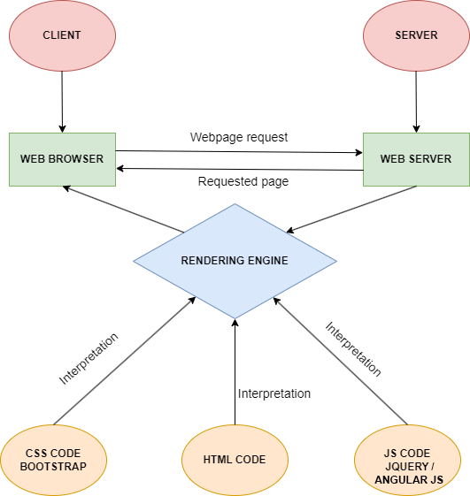

# DIAGRAM OF THE WEBSITE

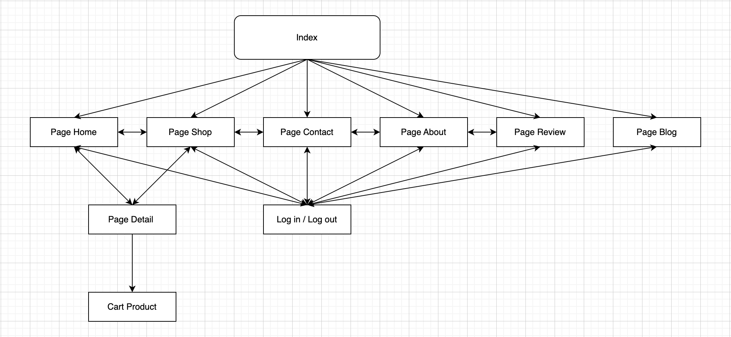

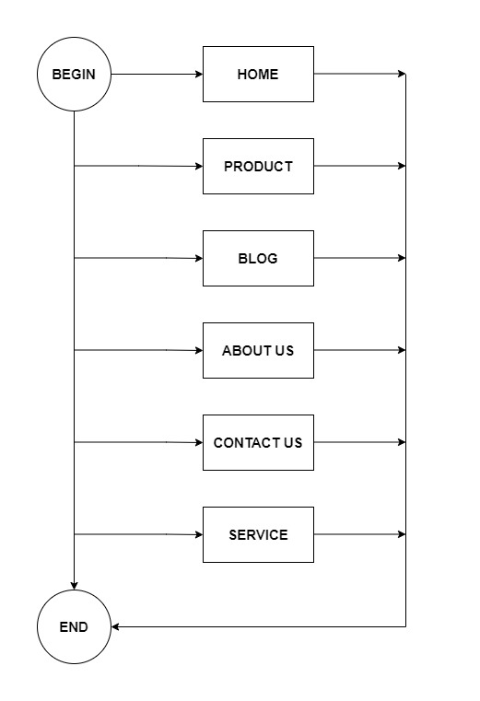

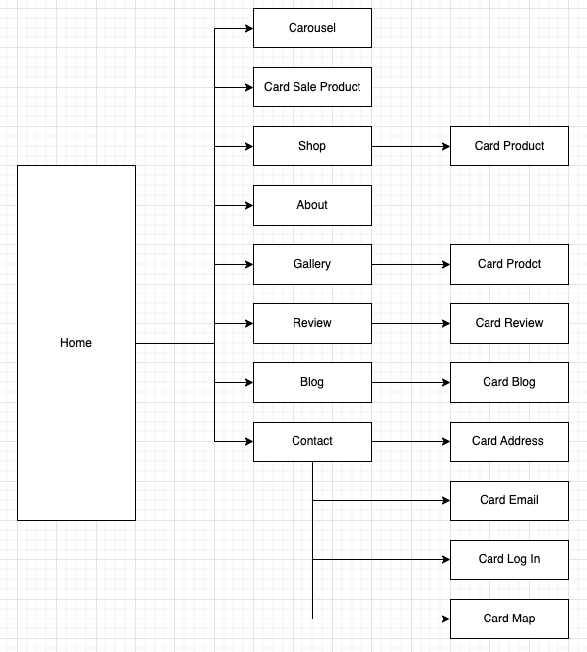



# TASK SHEET REVIEW 1

|  |  |  |  |  |  |  |  |
| --- | --- | --- | --- | --- | --- | --- | --- |
| **Project Ref. No.:**  **eP/Advertisement Portal Management**  **System/01** | | **Project Title:** | **Activity Plan Prepared By:** | **Date of Preparation of Activity Plan:** | | | |
| **Sr.**  **No.** | **Task** | **Actual**  **Start**  **Date** | **Actual Days** | **Team**  **Mate Names** | **Status** |
| 1 | Problem Statement | DCakeShop | Luong | 19-June-23 | 1 | Luong | Completed |
| 2 | Analysis of DCakeShop requirements about the website | 19-June-23 | 1 | Thien | Completed |
| 3 | The scope of the work (in brief) | 19-June-23 | 1 | Khanh | Completed |
| 4 | Architecture and design of the system | 19-June-23 | 1 | Danh | Completed |
| 5 | Diagram of the website | 19-June-23 | 1 | Luong | Completed |
| 6 | Task Sheet | 19-June-23 | 1 | Danh | Completed |

|  |  |
| --- | --- |
| **Date:** | |
| Signature of Instructor:  **Ms. Le Mong Thuy** | Signature of Team Leader:  **Ta Hai Luong** |

# SITE MAP

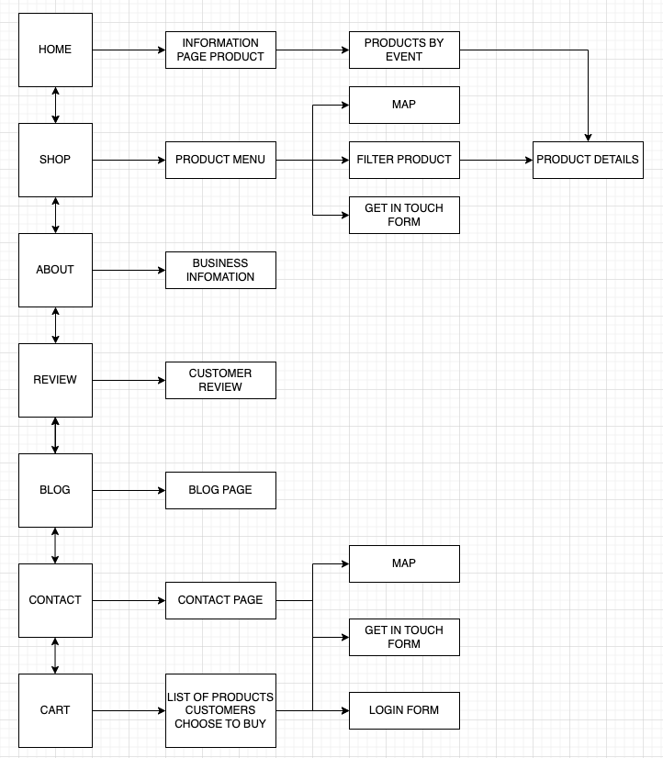

# 

# MOCK OF THE WEB SITE

1. **Home Page :**

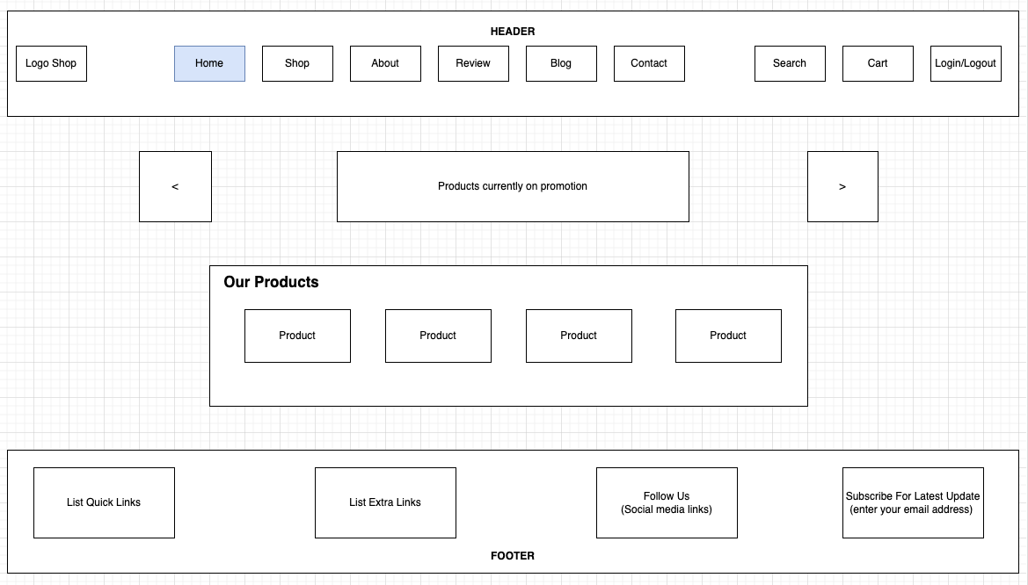

1. **Shop Page (product)**

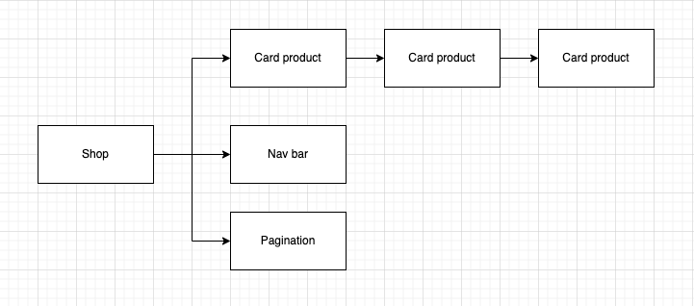

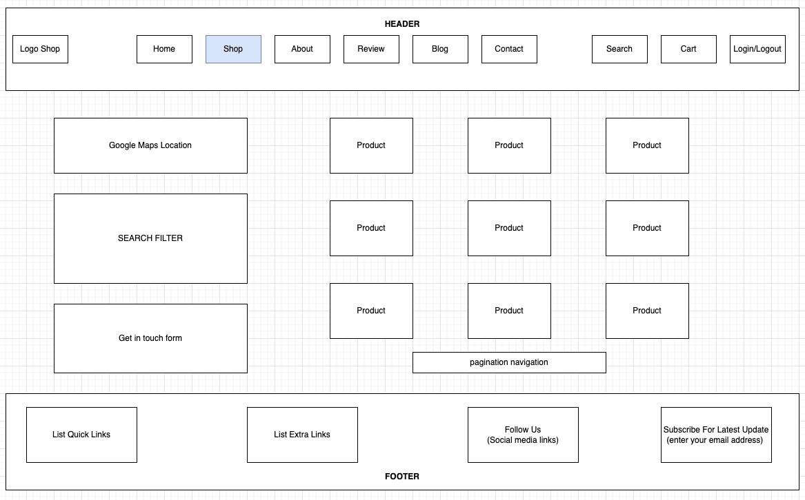

1. **About**

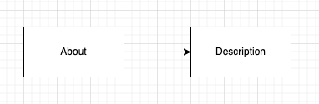

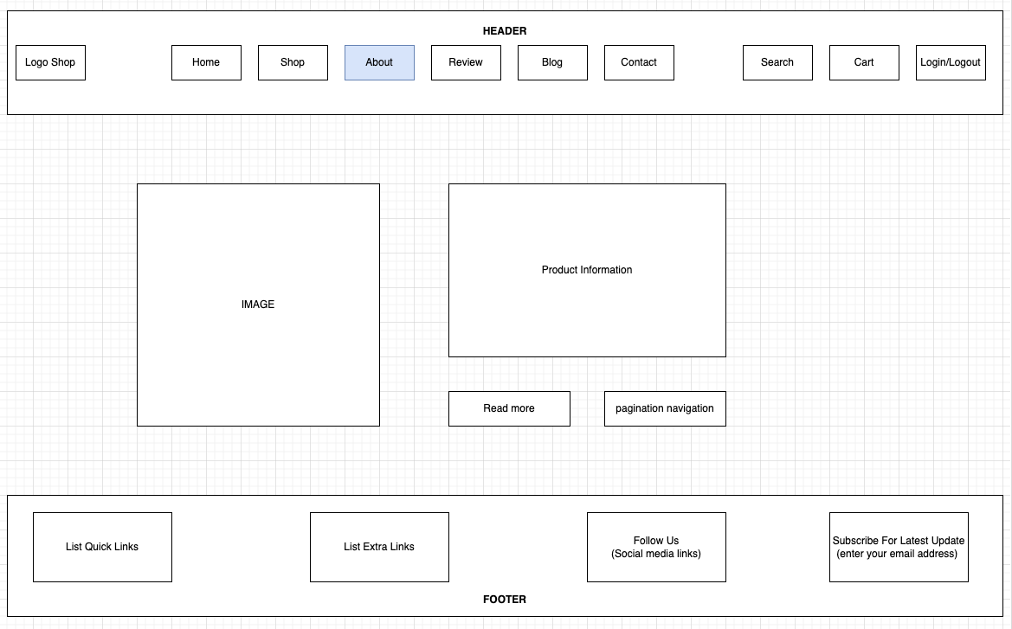

1. **Blog**

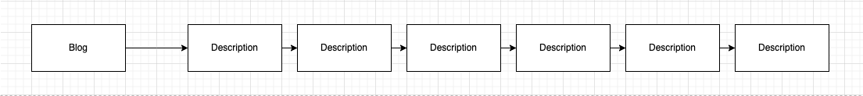

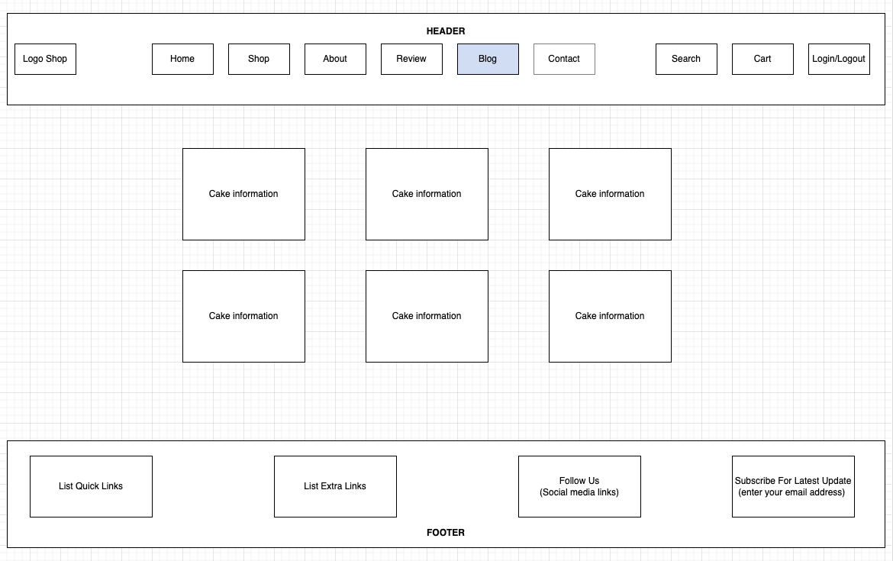

1. **Contact Us**

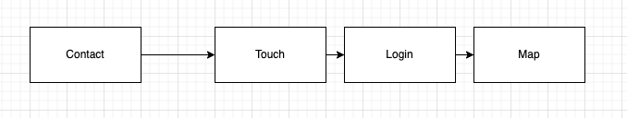

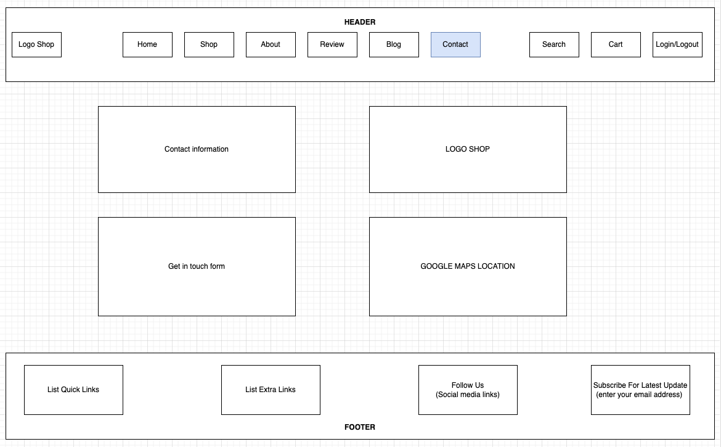

1. **Cart**

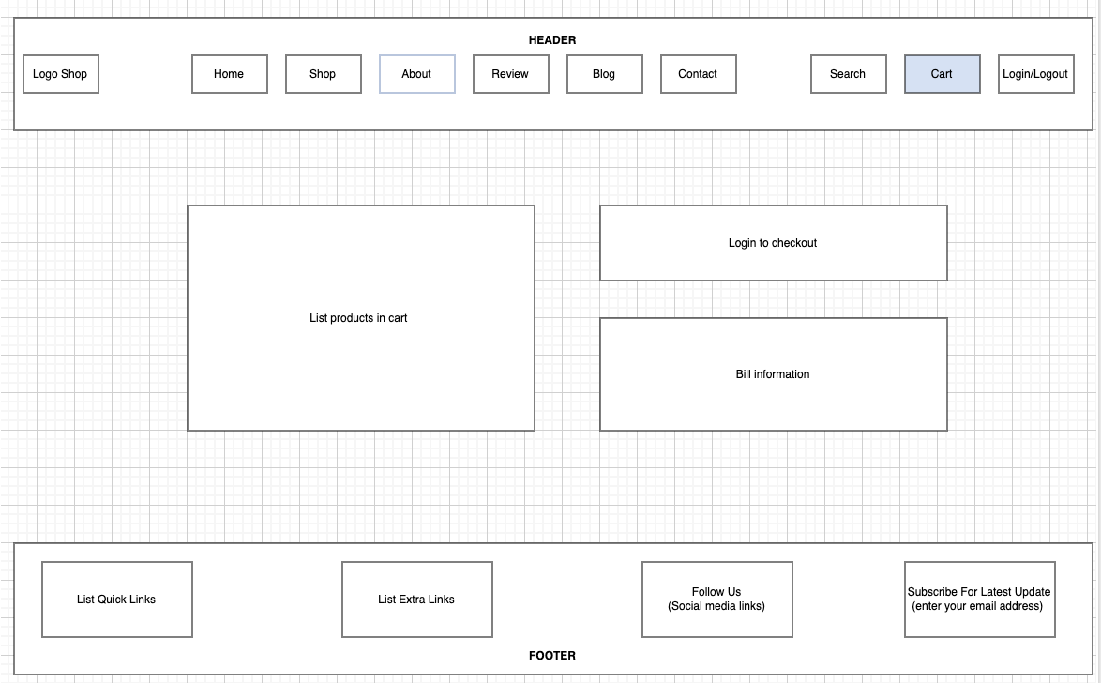

1. **Sign In/ Sign Up**

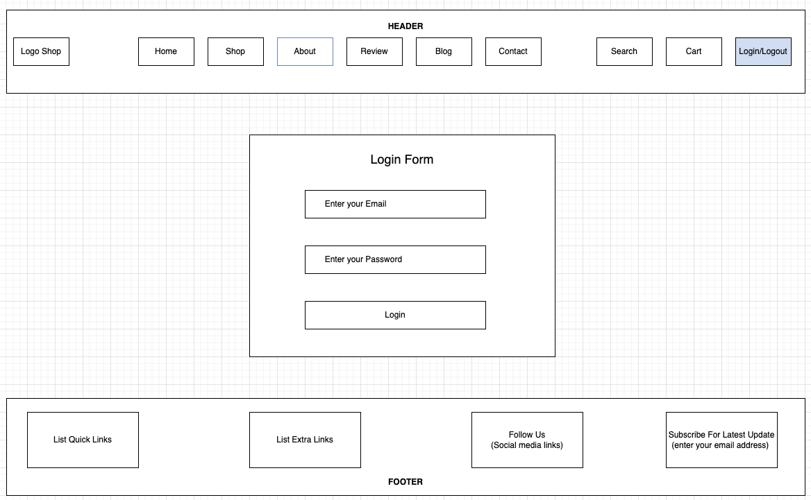

# 

# TASK SHEET REVIEW 2

|  |  |  |  |  |  |  |  |
| --- | --- | --- | --- | --- | --- | --- | --- |
| **Project Ref. No.:**  **eP/Advertisement Portal Management**  **System/01** | | **Project Title:** | **Activity Plan Prepared By:** | **Date of Preparation of Activity Plan:** | | | |
| **Sr.**  **No.** | **Task** | **Actual**  **Start**  **Date** | **Actual Days** | **Team**  **Mate Names** | **Status** |
| 1 | Site Map | DCakeShop | Phung | 21-June-23 | 1 | Danh | Completed |
| 2 | Mock of the website | 21-June-23 | 2 | Luong | Completed |
| 3 | Task sheet | 21-June-23 | 2 | Khanh + Thien | Completed |

|  |  |
| --- | --- |
| **Date:** | |
| Signature of Instructor:  **Ms. Le Mong Thuy** | Signature of Team Leader:  **Ta Hai Luong** |

# 

# WEBSITE DESCRIPTION

1. **Homepage**
2. Description

Home page displays following information:

- Slide show programs, services and product promotions

- Feature product.

- Latest news (Blog).

- Popular Brand.

- Some information about the website.

1. Screen shot

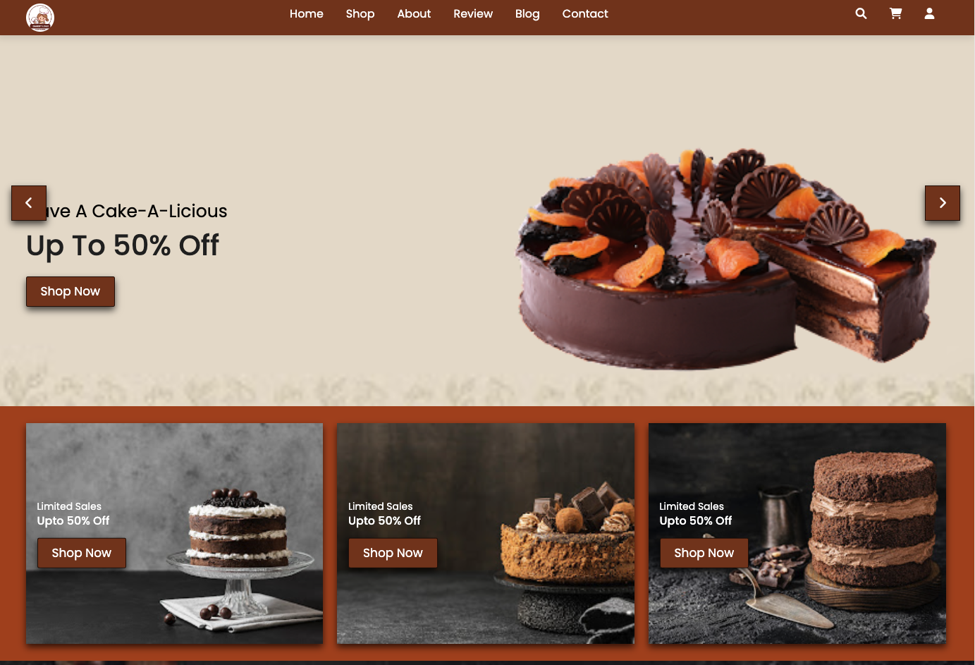



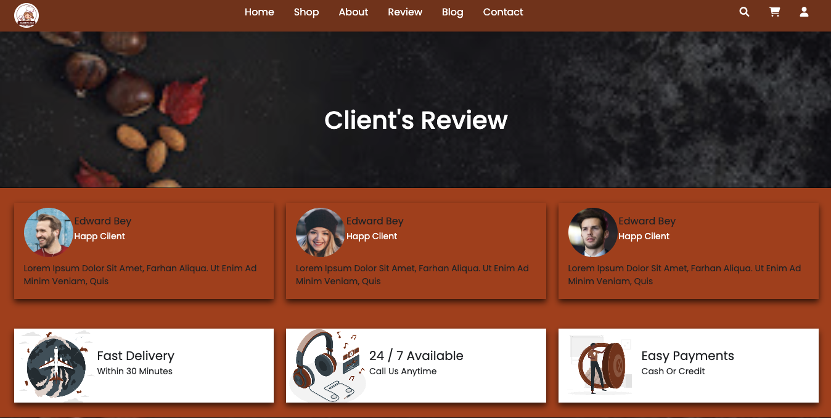

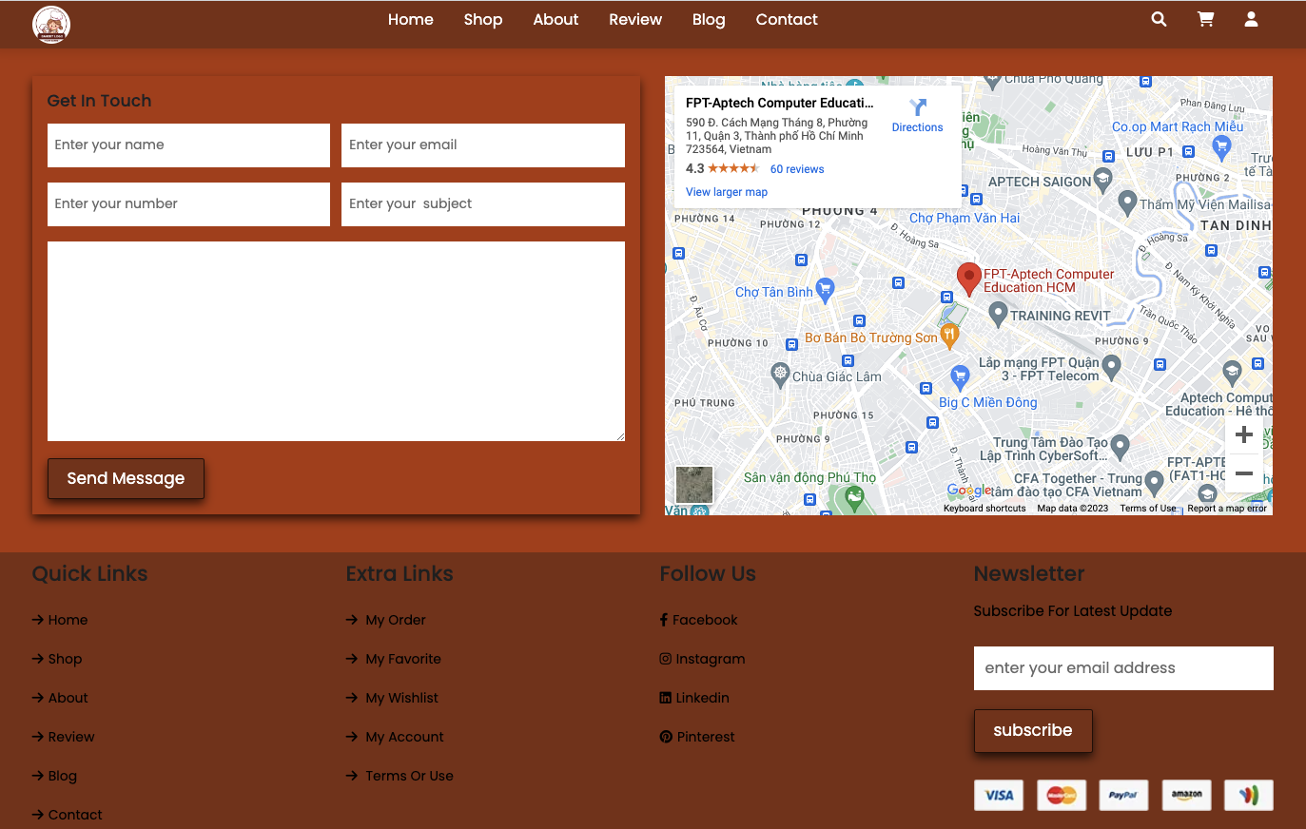

1. **Product**
2. Description

This product page displays following information:

- All product that being sold at Harvel Electric (LED & Lighting, FANs, Cables & Wires, Switches & Automation, Protection Devices, Appliances), when click on quick view item, it will show the detail of that item.

- Products can be compared with products of the same category

- Menu filter to easily find items based on categories.

- Product can sort by price and by name.

1. Screen shot

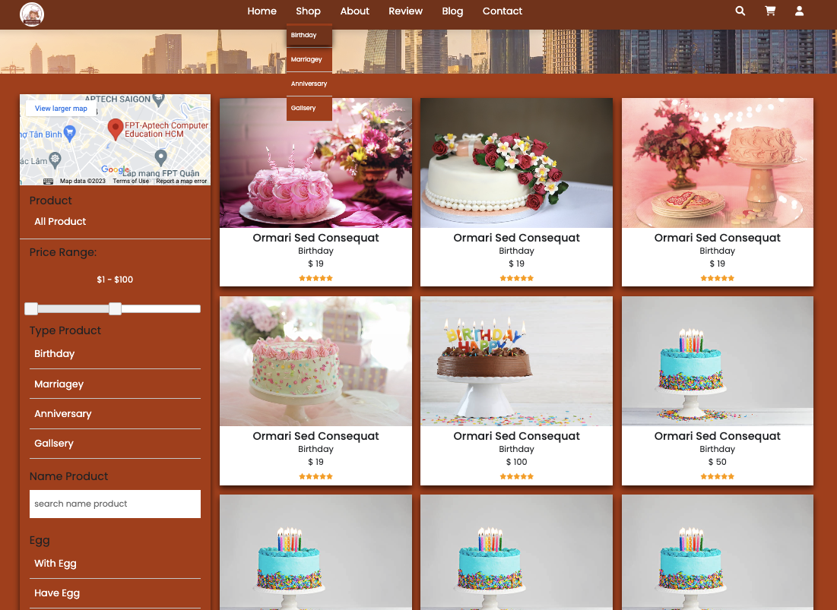

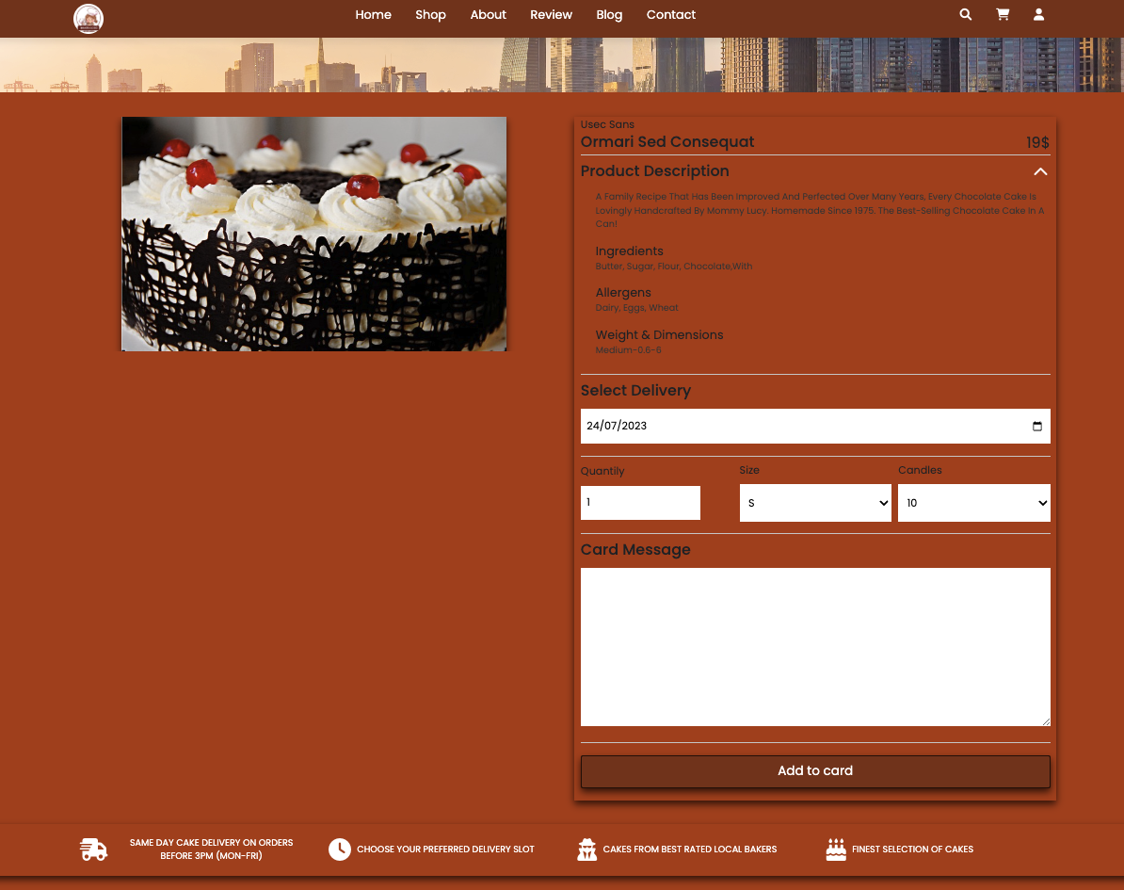

1. **Blog**
2. Description

The blog page displays following information:

- News.

- Information of product.

- Events, promount.

1. Screen shot

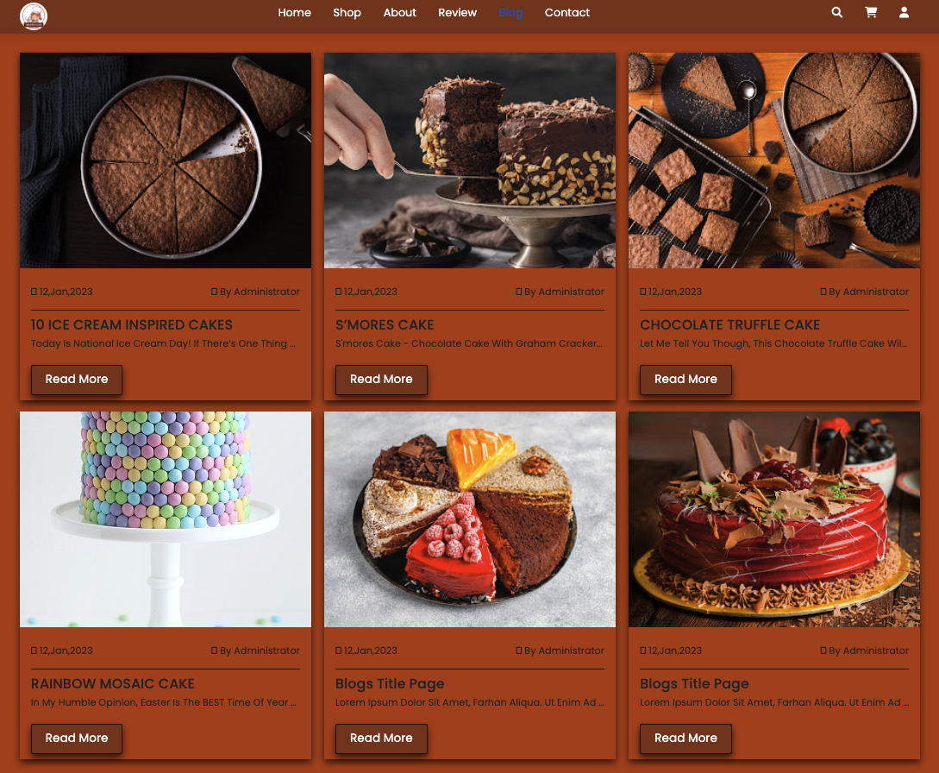

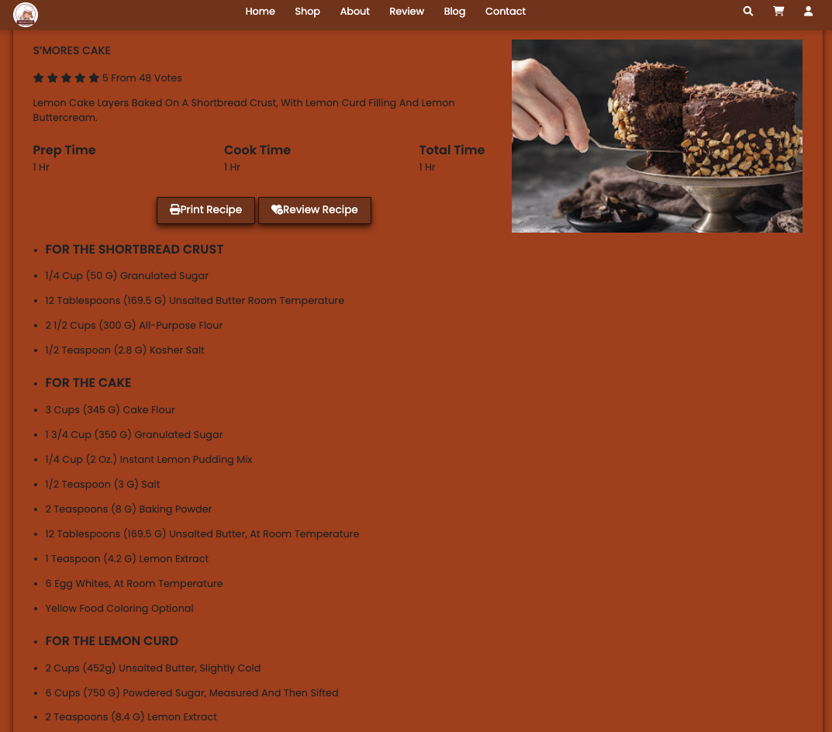

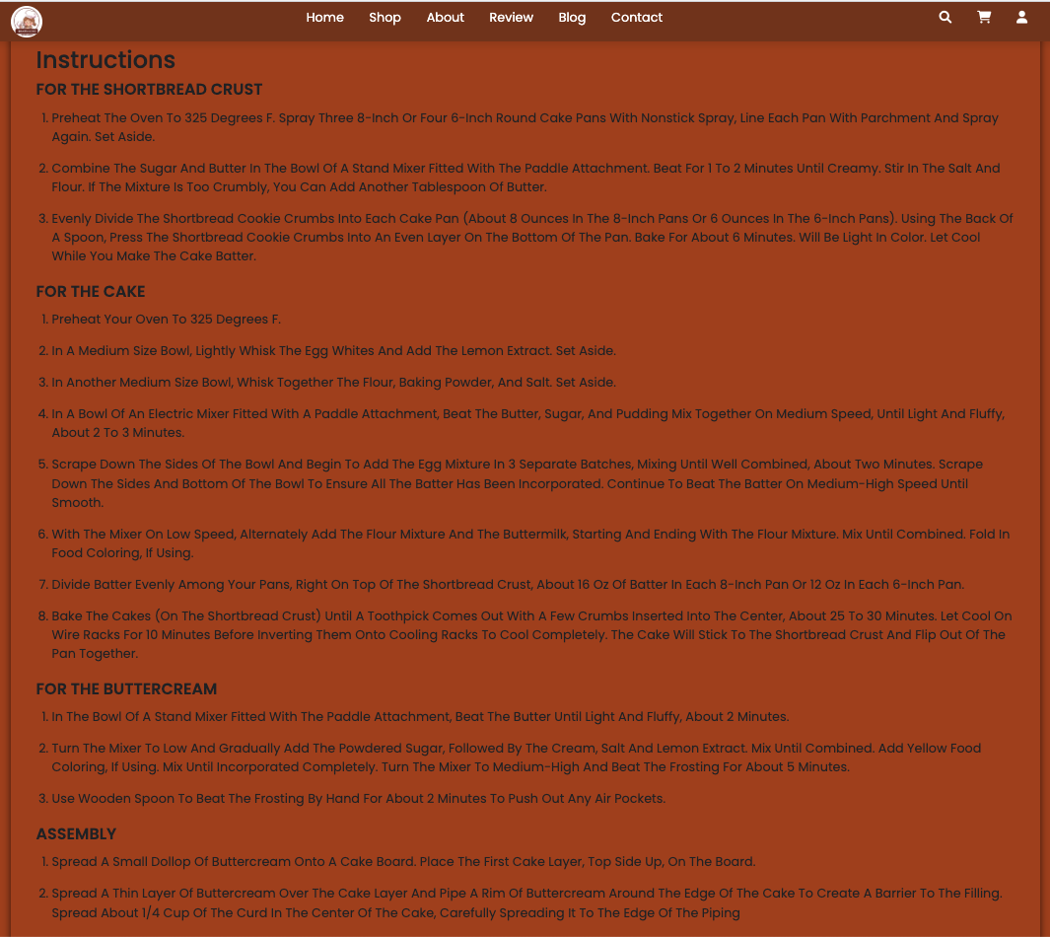

1. **About Us**
2. Description

- This page displays information about the history of Rhythm House, our service that we provide and mission of our team.

1. Screen shot

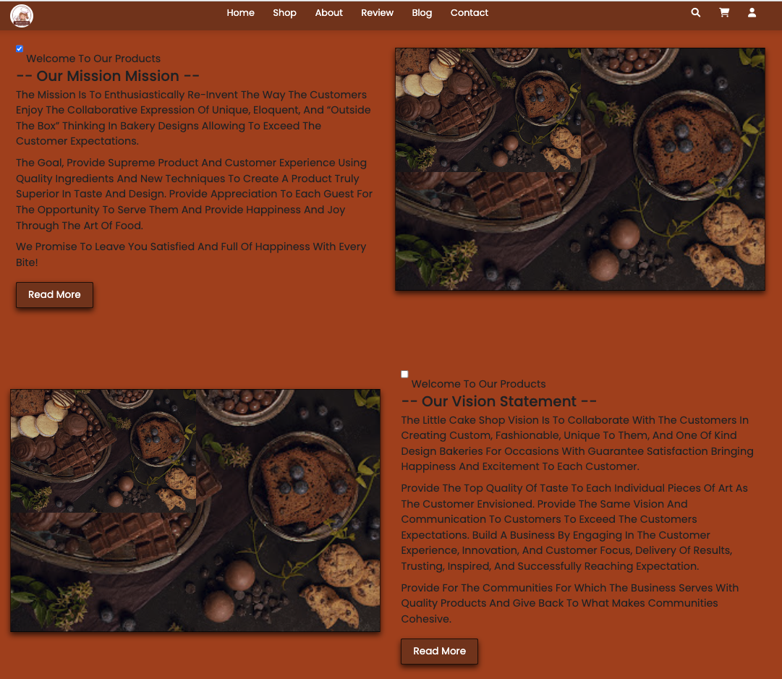

1. **Contact Us**
2. Description

This page displays contact information: location, telephone number, email and a quick contact form for customer

1. Screen shot

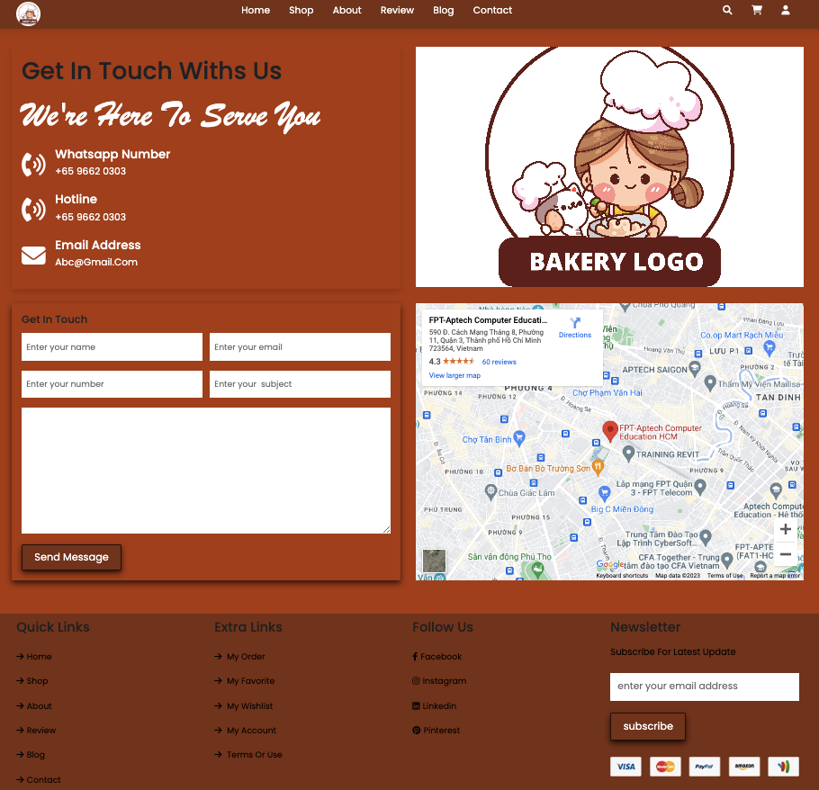

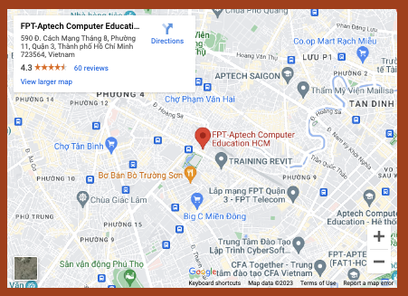

1. **Add To Card**
2. Description

- This page displays information: product customers have added to cart

- Login to pay bill or continue shopping

1. Screen shot

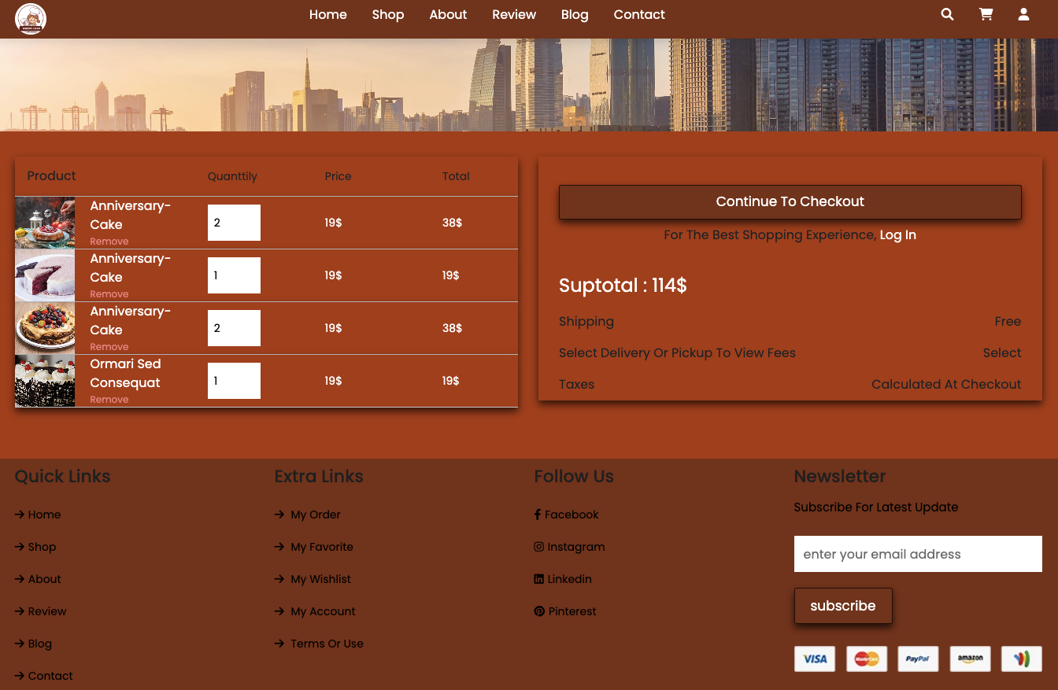

1. **Login/ Register**
2. Description

- This page display form allow input email and password.

- Validate if incorrect password

1. Screen shot

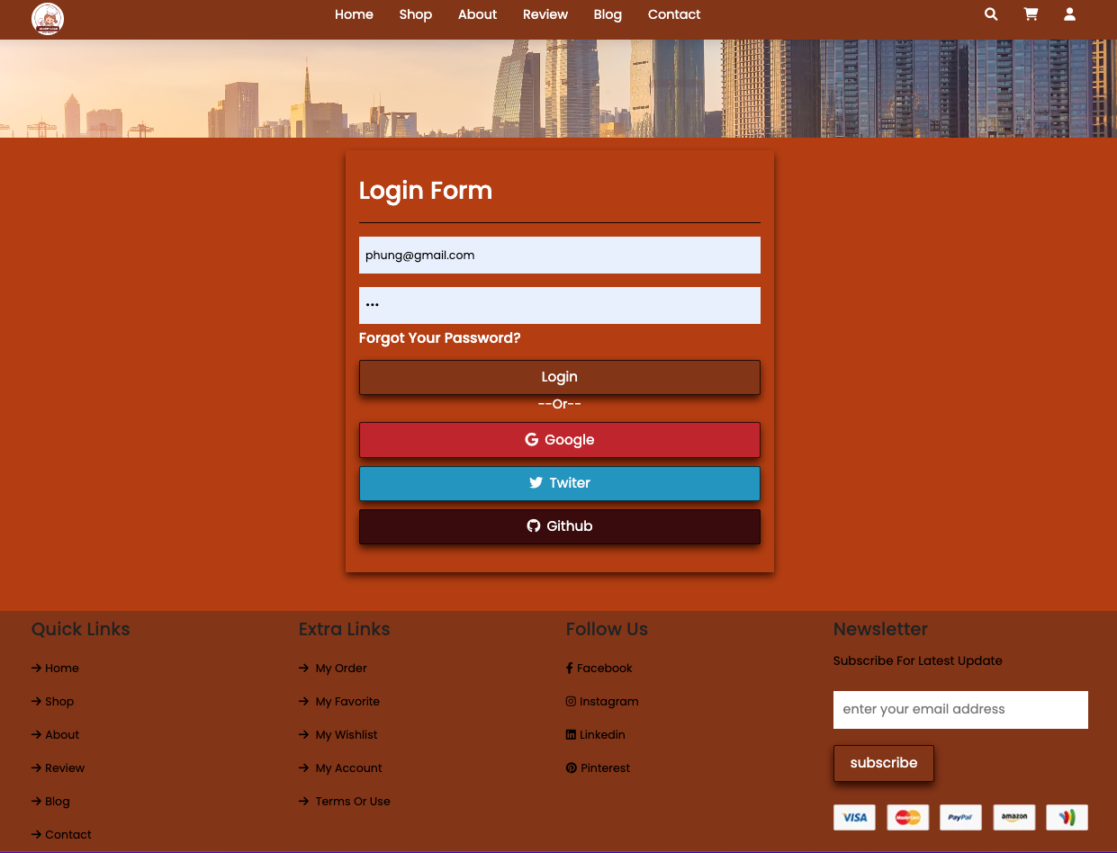

**Incorrect password**

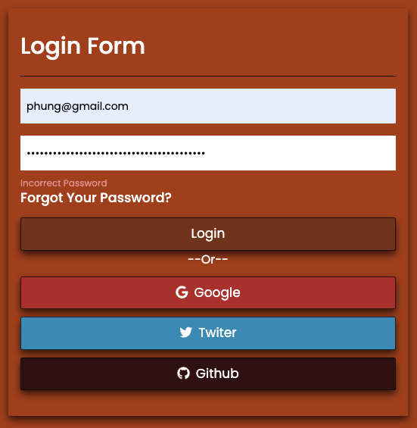

**Login successfully :**

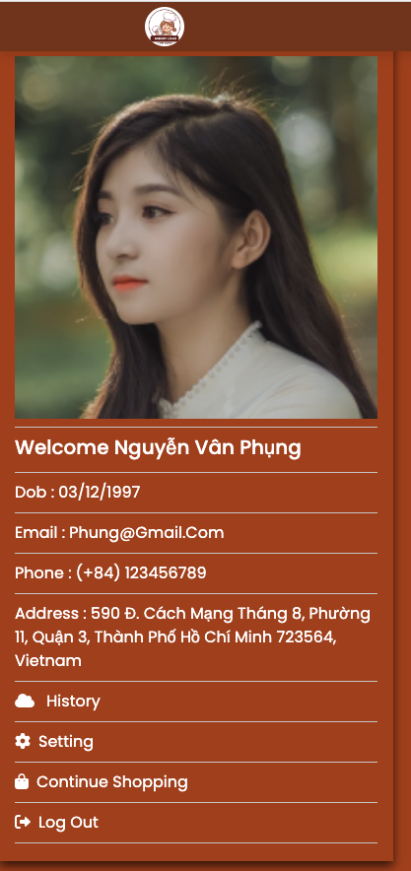

**JAVASCRIPT DESCRIPTION**

1. **Route Javascript**
2. Description

This script is used to display product details in a modal format. Inside there are more products of the same type

1. Screen shot

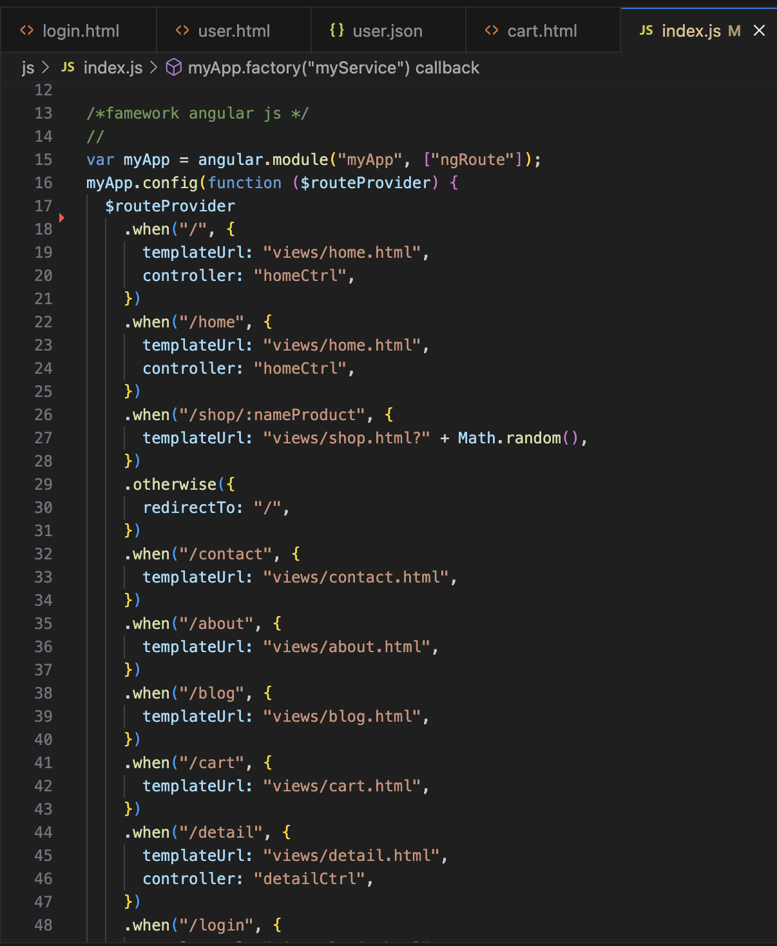

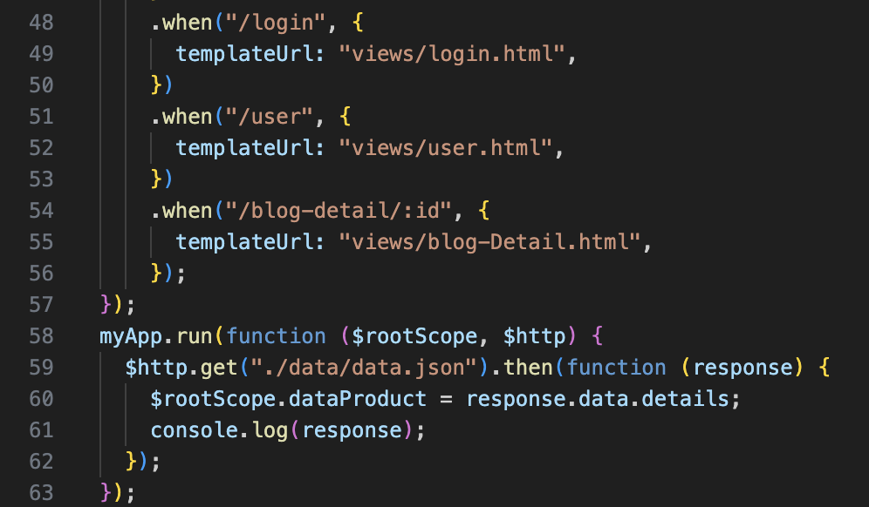

1. **Factory Javascipt :**
2. Description

This script used for display home page

1. Screen shot

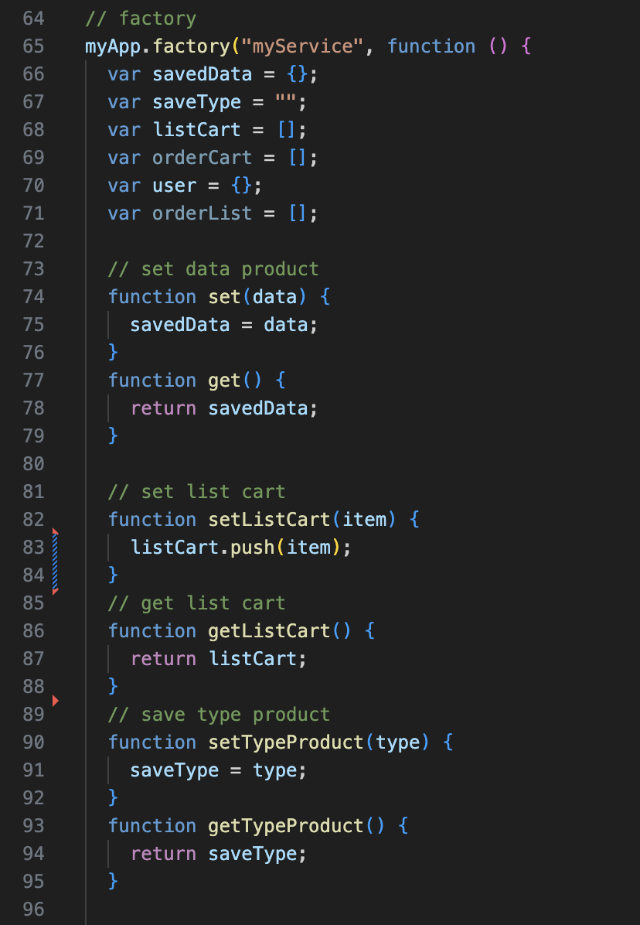

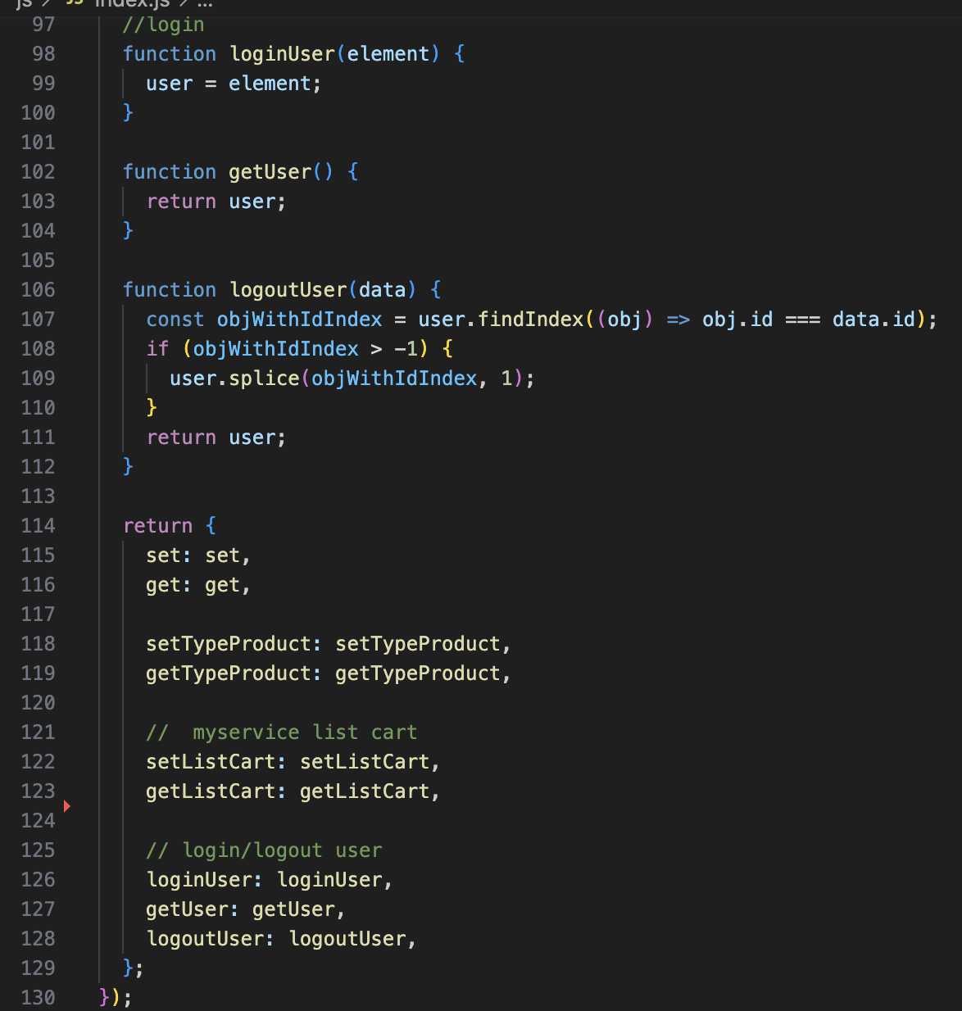

1. **Filter Javascript (Filter price, product)**
2. Description

- This script is used to filter the product list by Price, Egg

- Users can adjust the price to filter products in the selected price bracket

1. Screen shot

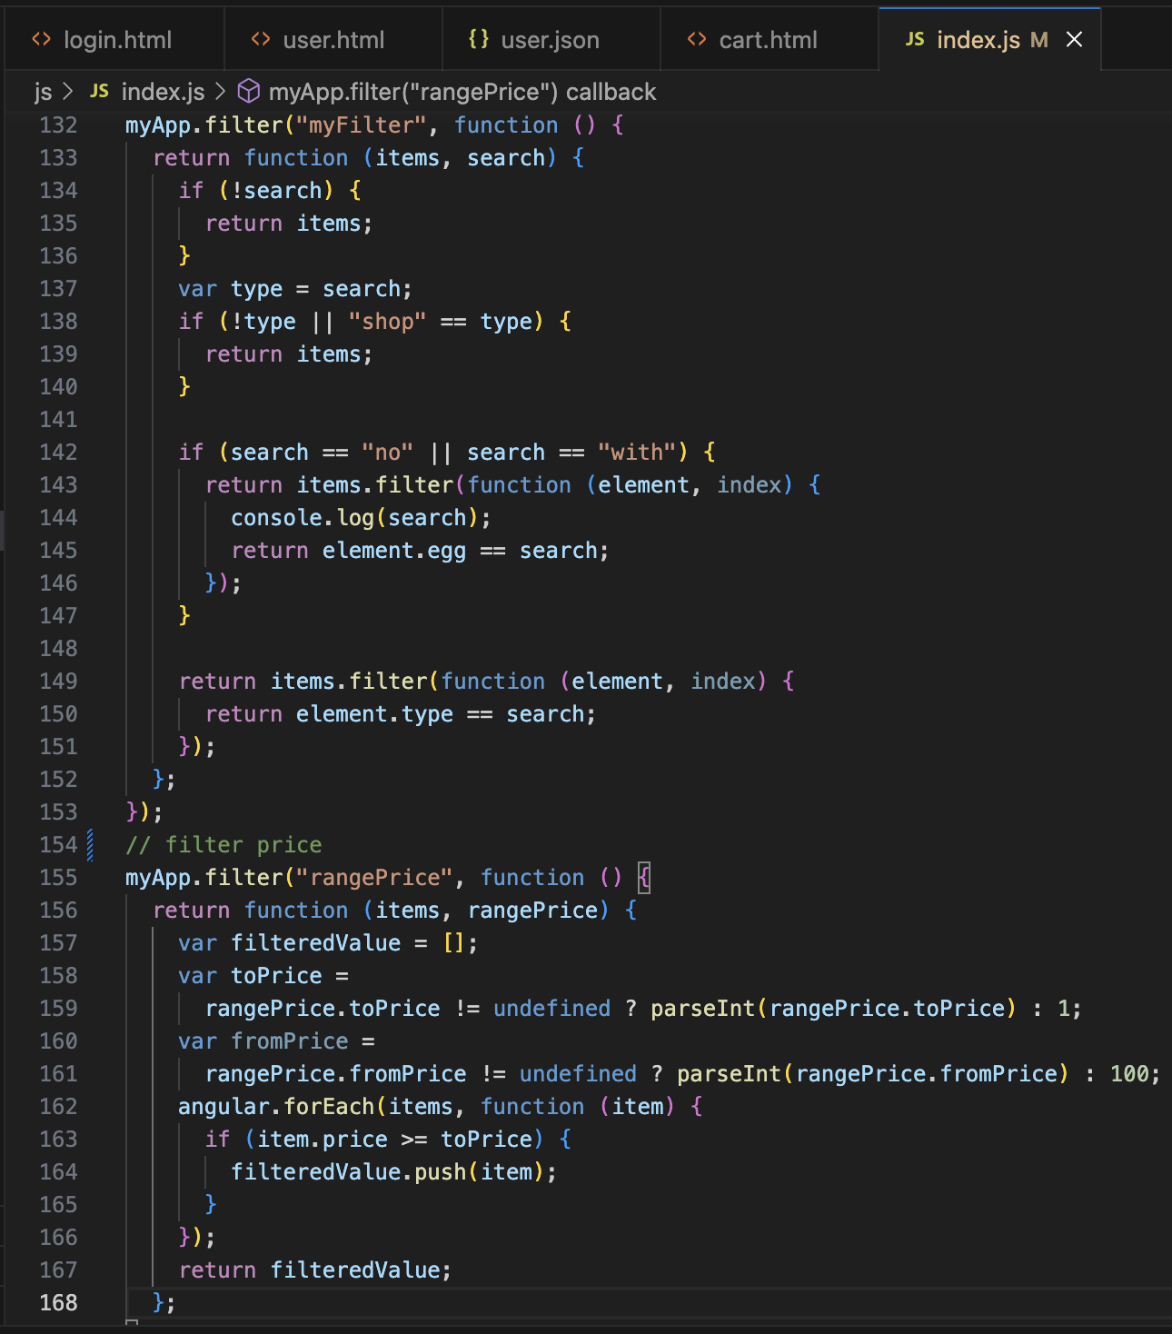

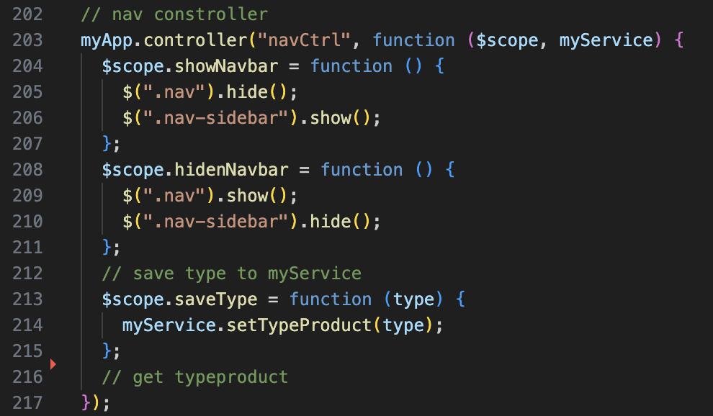

1. **Home Javascript**
2. Description

This script used for display home page

1. Screen shot

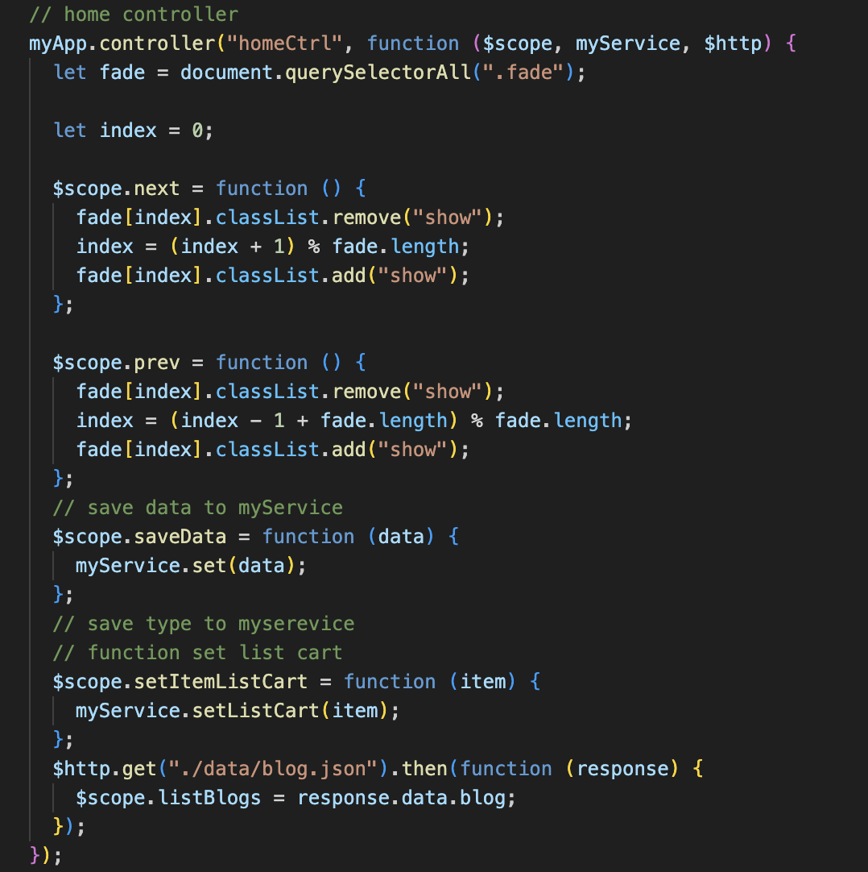

1. **Product Javascript (Shop Page)**
2. Description

This script is used to display all products (filter by type : anniversary, marriage, birthday,…)

1. Screen shot

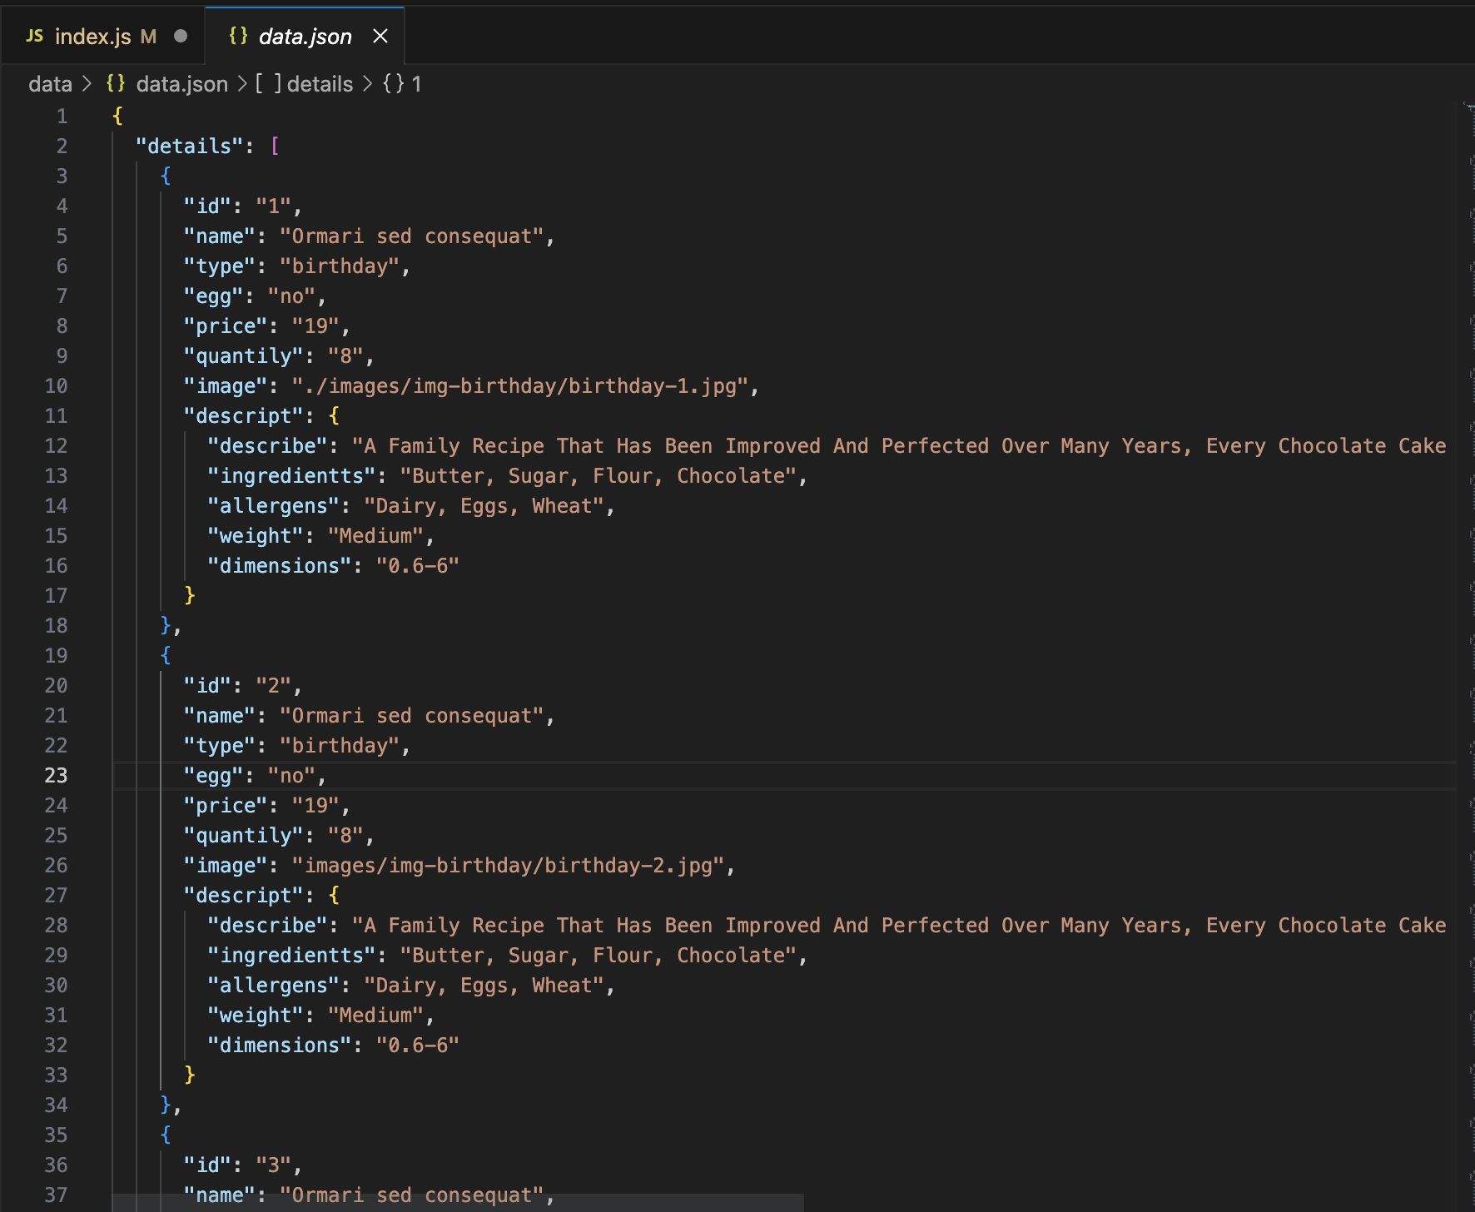

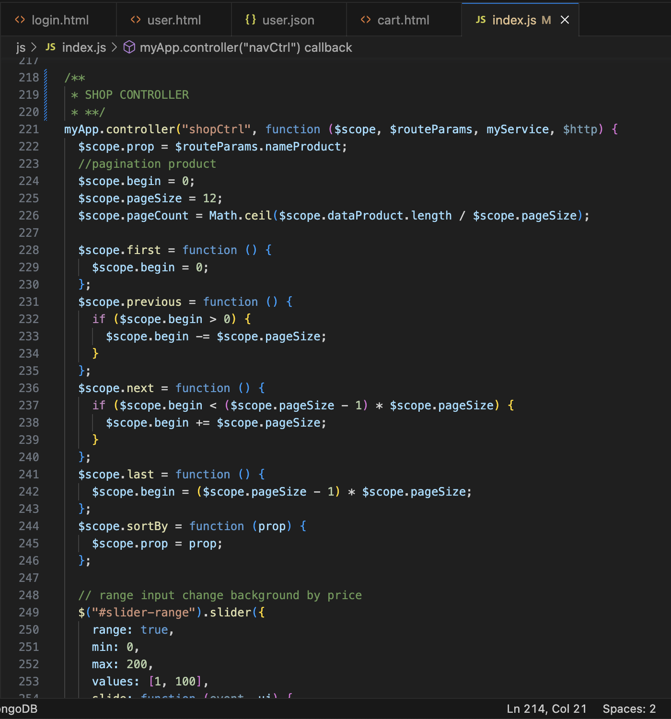

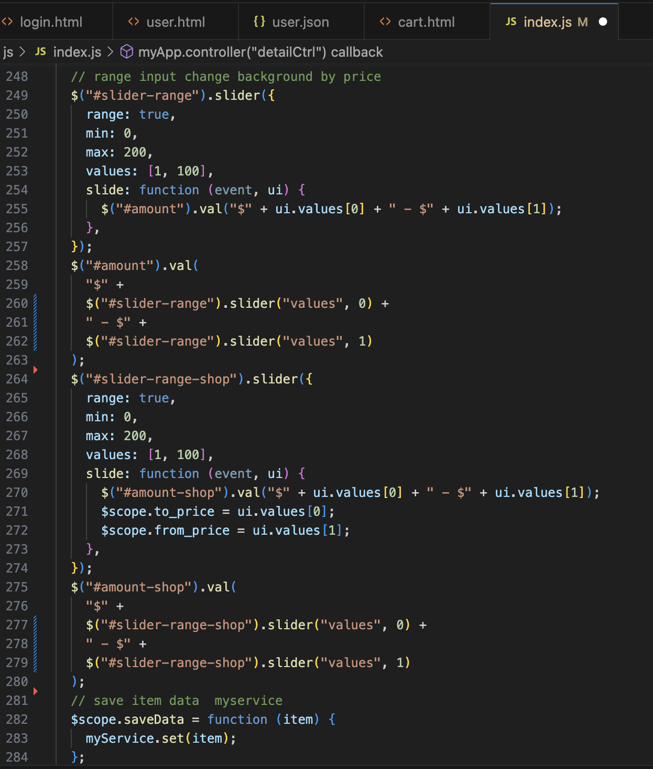

1. **Add to Cart - Javascript**
2. Description

This script used for customer add products to cart and pay

1. Screen shot

# 

# 

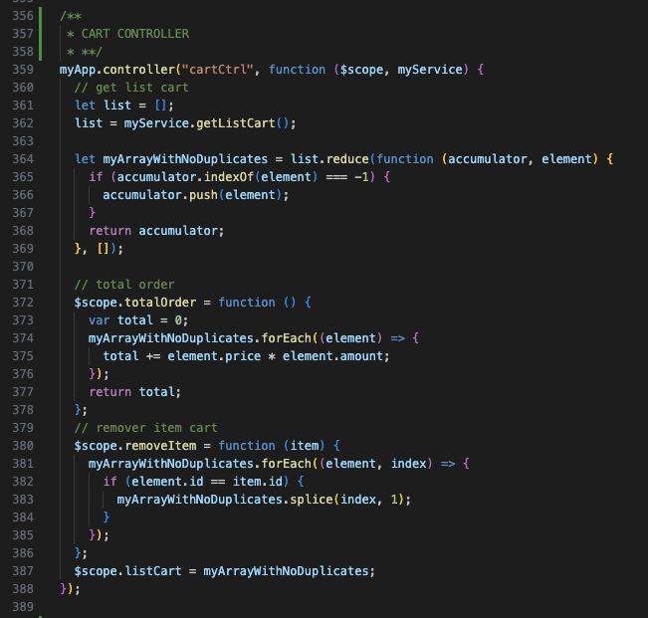

1. **Contact Javascript**
2. Description

This script is used to compare products of the same category

1. Sreen shot

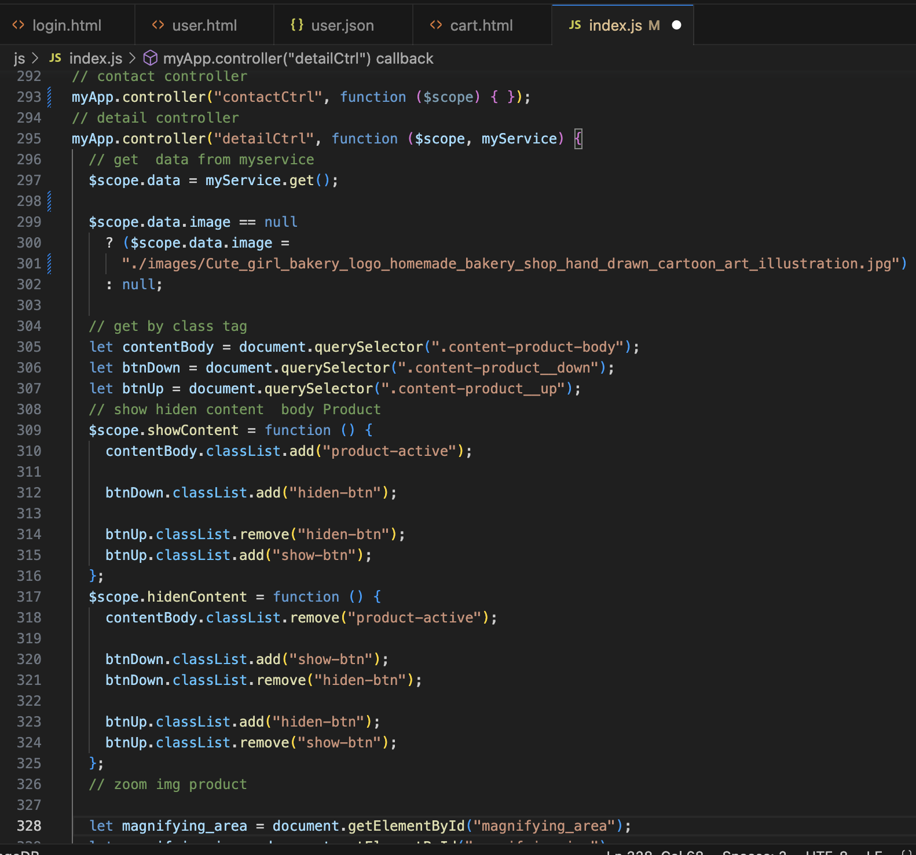

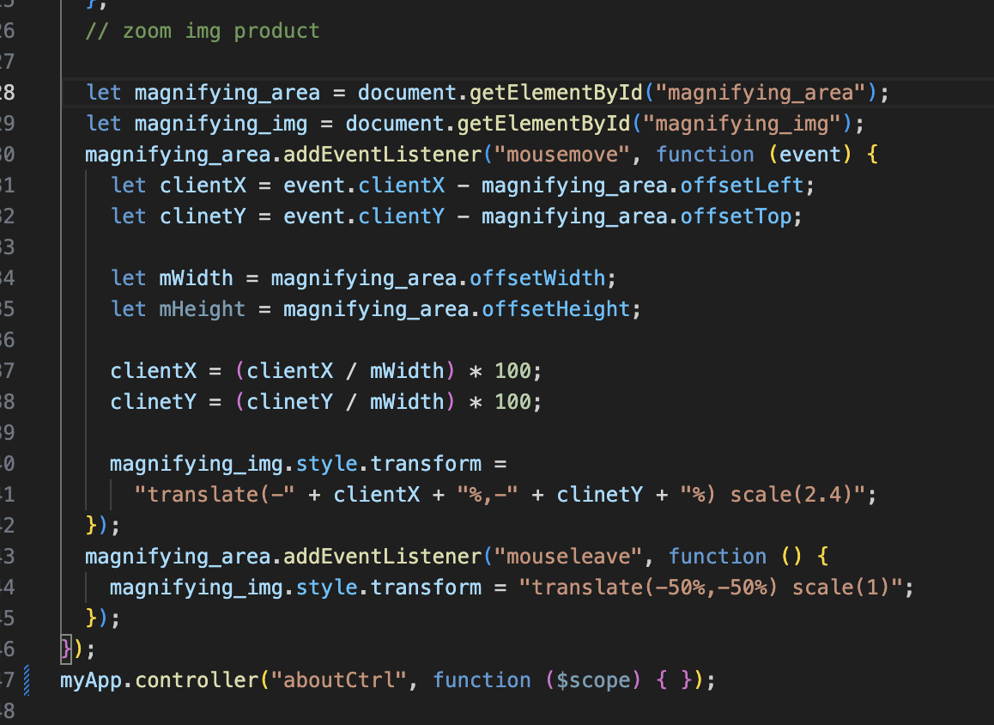

1. **Blog Javascript**
2. Description

This script is used to paginate products into pages, each with twelve products

1. Sreen shot

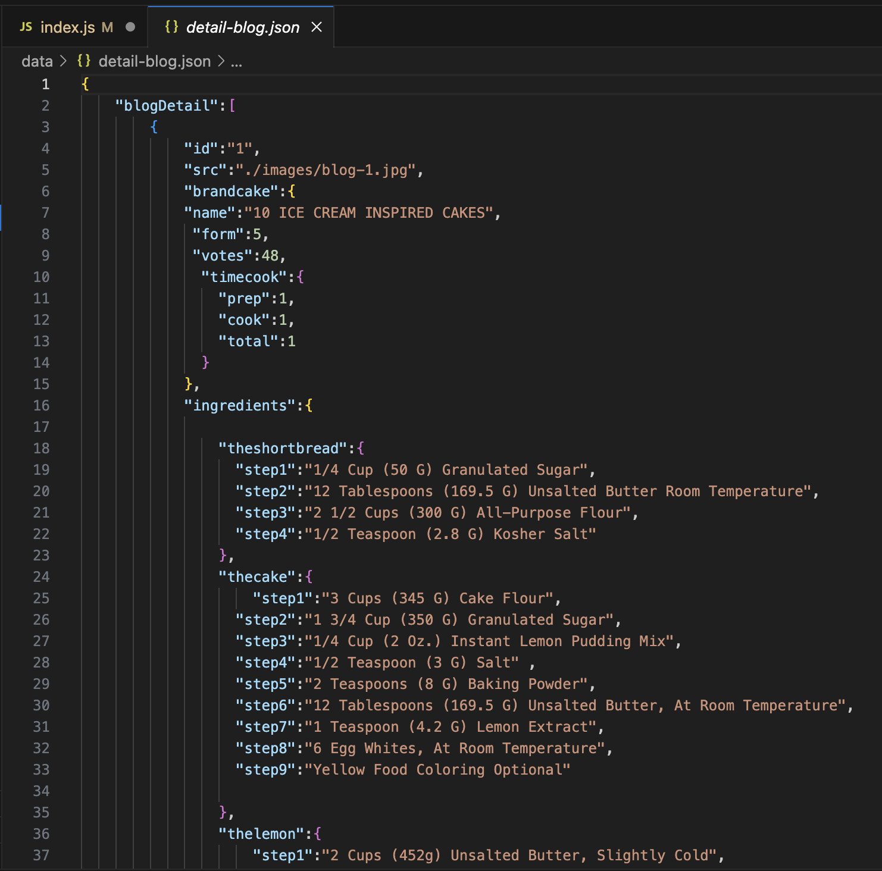

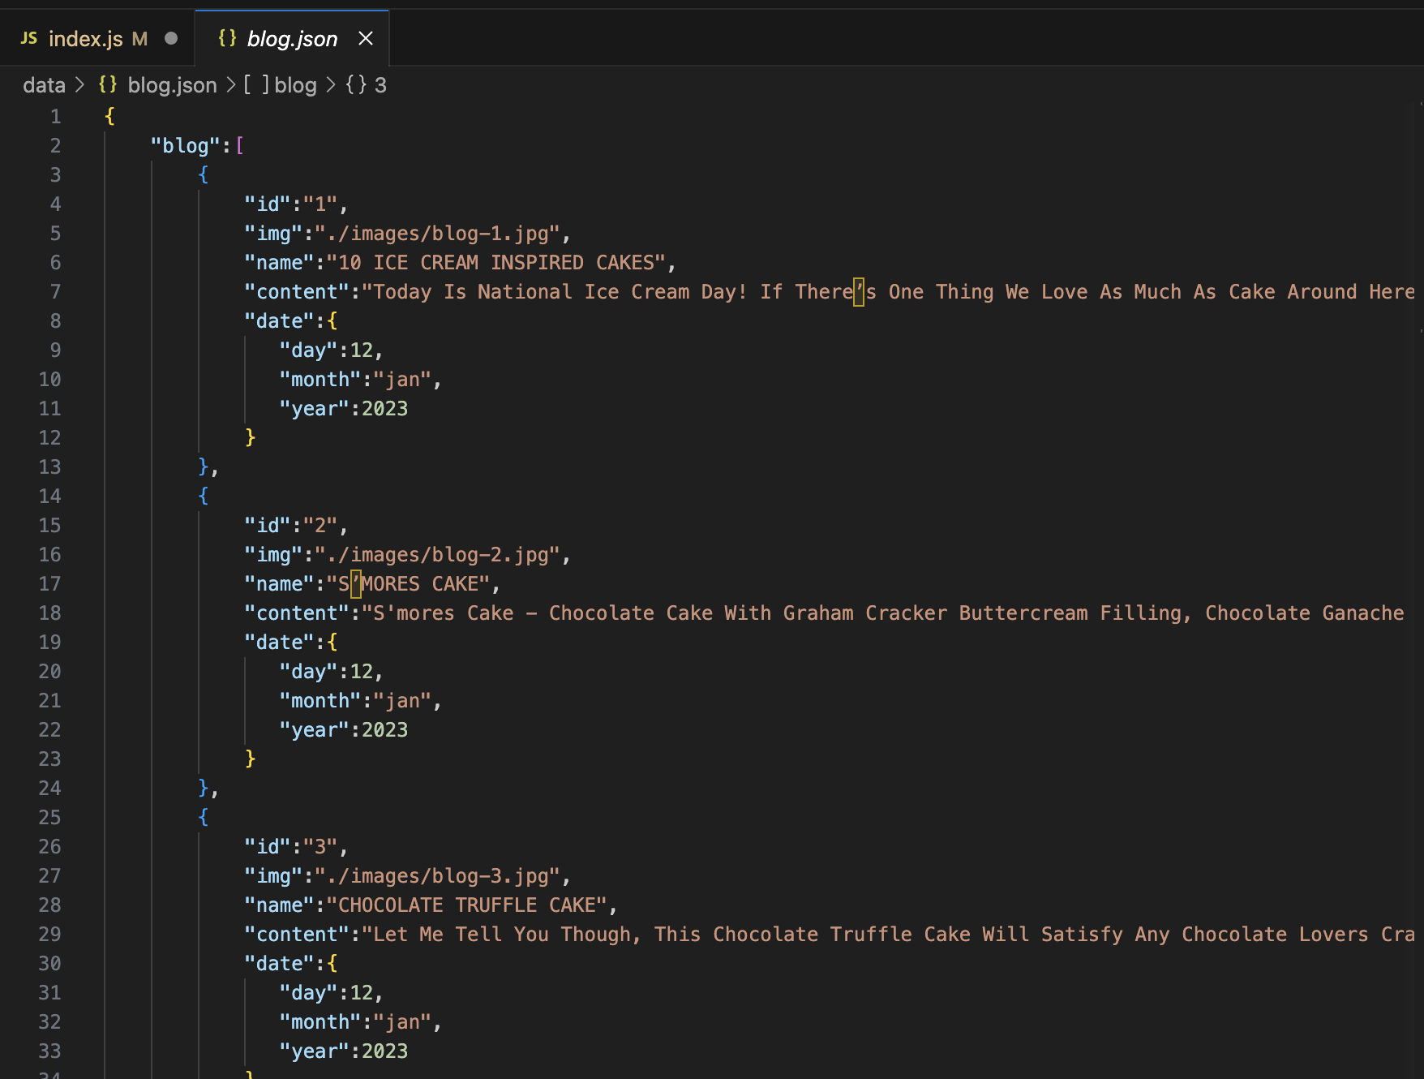

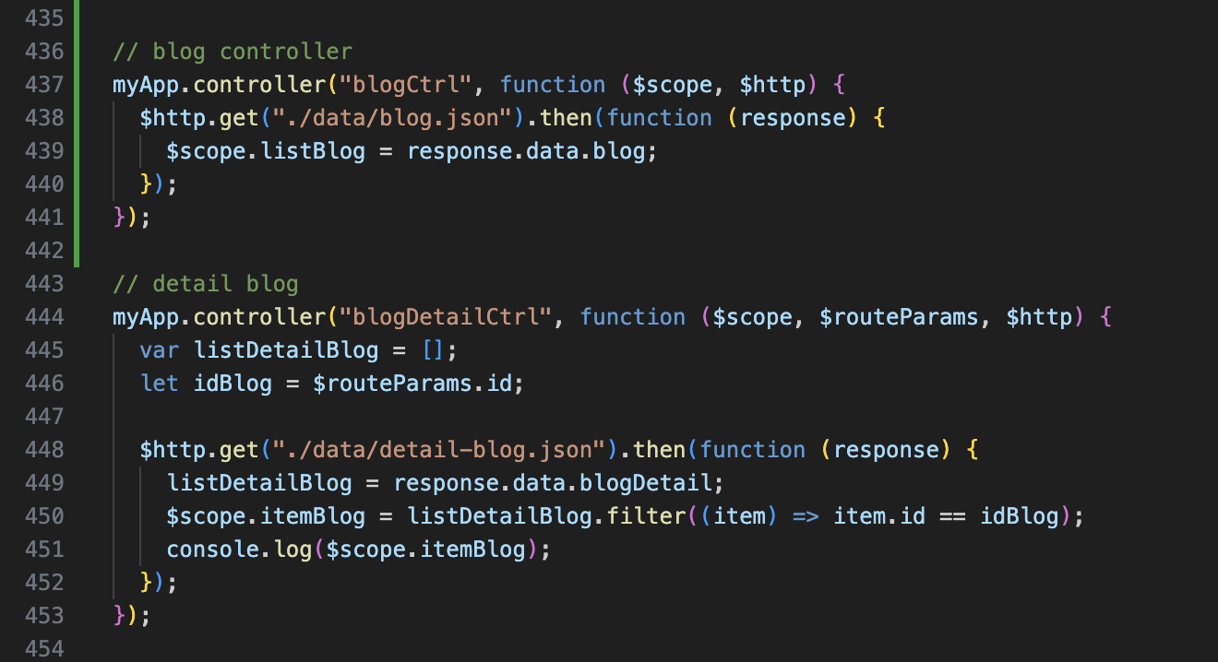

1. **Sign-in & Sign-up Javascript**
2. Description

This script used for member registration and login in the website.

1. Screen shot

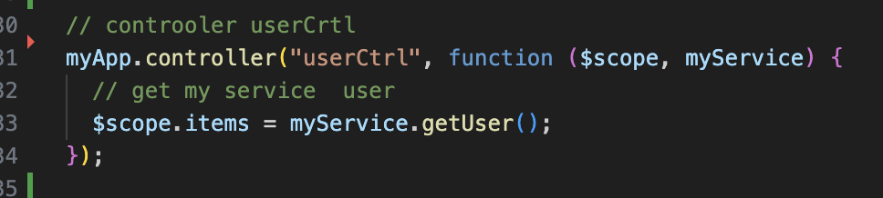

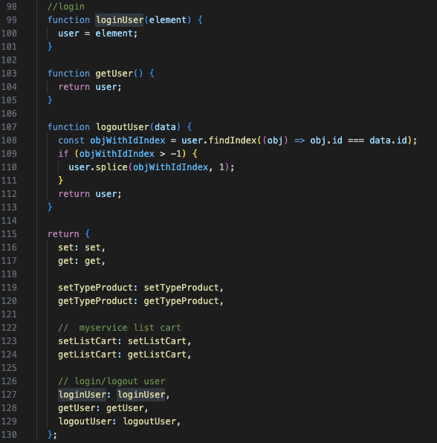

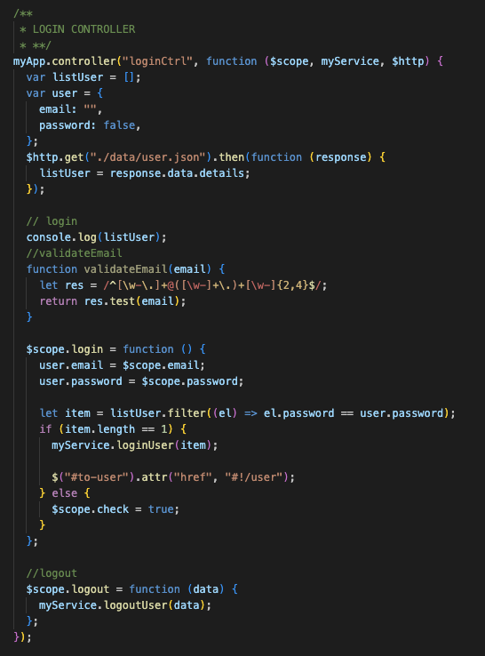

# 

1. TASK SHEET REVIEW 3

|  |  |  |  |  |  |  |  |
| --- | --- | --- | --- | --- | --- | --- | --- |
| **Project Ref. No.:**  **eP/Advertisement Portal Management**  **System/01** | | **Project Title:** | **Activity Plan Prepared By:** | **Date of Preparation of Activity Plan:** | | | |
| **Sr.**  **No.** | **Task** | **Actual**  **Start**  **Date** | **Actual Days** | **Team**  **Mate Names** | **Status** |
| 1 | Home Page | DCAKESHOP | Luong | 18-July-21 | 1 | Danh | Completed |
| 2 | Product | 20-July-21 | 3 | Luong | Completed |
| 3 | Filter Product | 20-July-21 | 3 | Luong | Completed |
| 4 | Blog | 20-July-21 | 2 | Thien | Completed |
| 5 | About Us | 20-July-21 | 2 | Khanh | Completed |
| 6 | Contact Us | 20-July-21 | 2 | Danh | Completed |
| 7 | Cart | 20-July-21 | 3 | Thien | Completed |
| 8 | Sign In/ Sign Up | 20-July-21 | 2 | Khanh | Completed |
|  |  |  |  |  |  |
|  |  |  |  |  |  |

|  |  |
| --- | --- |
| **Date:** | |
| Signature of Instructor:  **Ms. Le Mong Thuy** | Signature of Team Leader:  **Ta Hai Luong** |